Race to 200

Take turns to play.
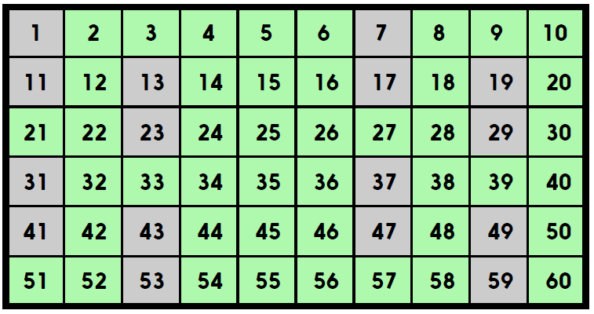
- Choose one of the green numbers and cross it off.
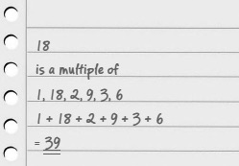
Write down all the numbers that your number is a multiple of.
Finally, add together all of those numbers to create a ‘factor sum’. This number is your score for this round.
- Now it is the other player’s turn to do the same.

- Keep taking turns. The winner is the first player to reach a total of 200! If both/all players reach 200 in the same round, the winner is the player closest to 200, so be careful which number you pick as the game nears its end.
How might you keep track of people’s scores?
- Will the biggest number always have the highest ‘factor sum’?

Challenge
Write something you notice about the grey numbers.
Do you think it would be helpful to have these numbers in the game? Explain your ideas.

