Mystery age

- Three primary school children are trying to guess their Mum’s age. Can you help them?

- They know only that she is between 30 and 40 years old.
She gives them some clues:

- Multiply Sam’s age by 4, then add 3 to get my age.
- Multiply Amy’s age by 5, then add 1 to get my age.
- Multiply Max’s age by 3, then add 1 to get my age.

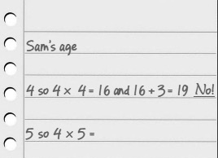
- Work out their Mum’s age AND all their ages.

Challenge
Write your own clues to work out Dad’s age, 34. Get another child/pair to try them out.

