[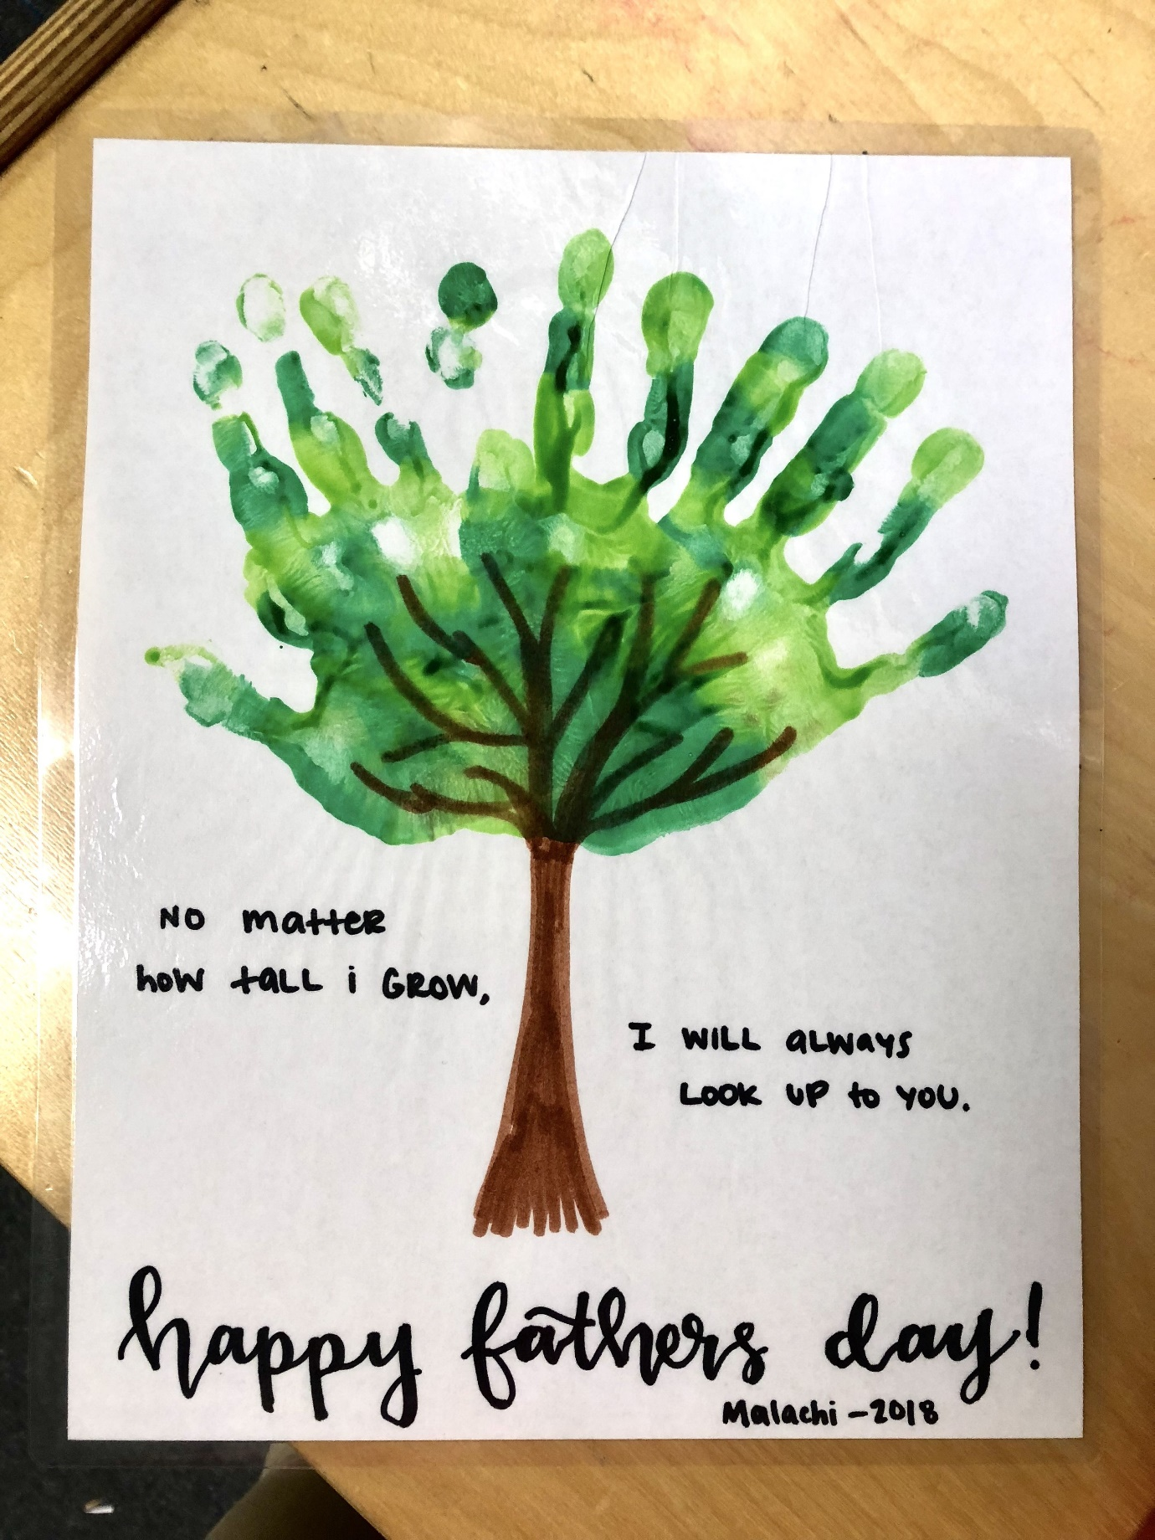](https://www.google.co.uk/url?sa=i&url=https%3A%2F%2Fwww.pinterest.com%2Fpin%2F810788739143667677%2F&psig=AOvVaw2G1mpVDggZNxn3Jk7OG9hX&ust=1591812041621000&source=images&cd=vfe&ved=0CAIQjRxqFwoTCOiZxo2o9ekCFQAAAAAdAAAAABAD)