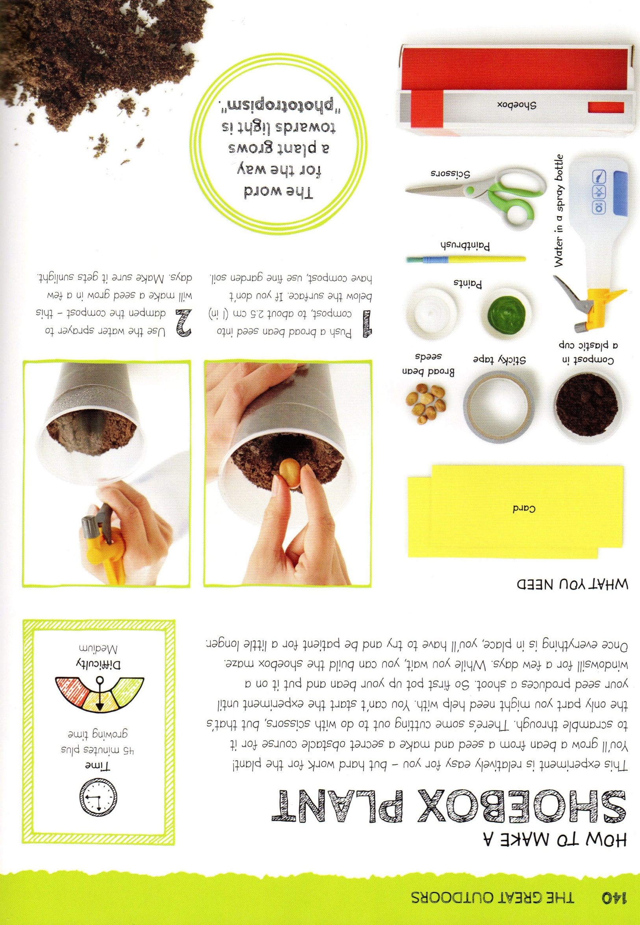
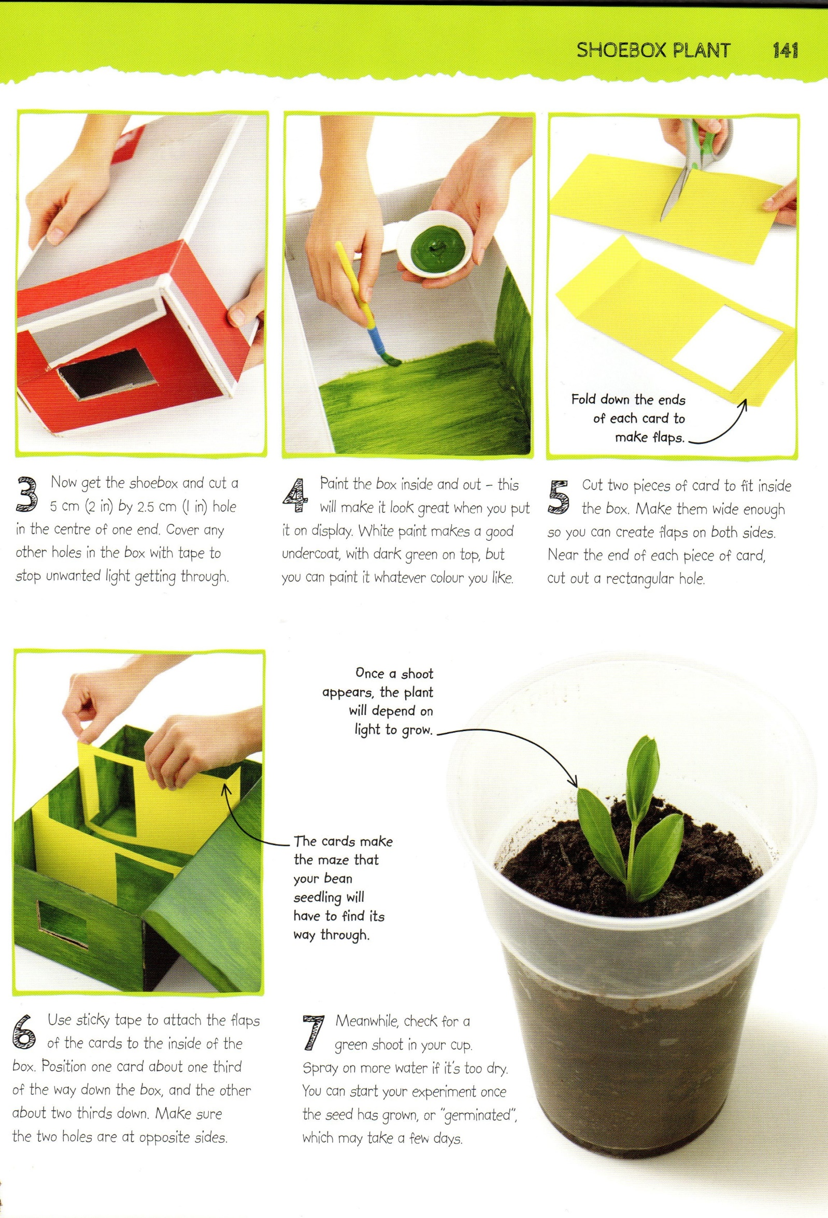
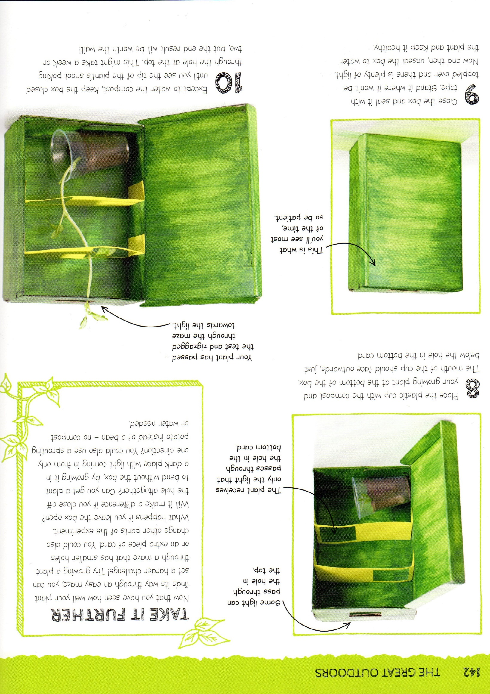
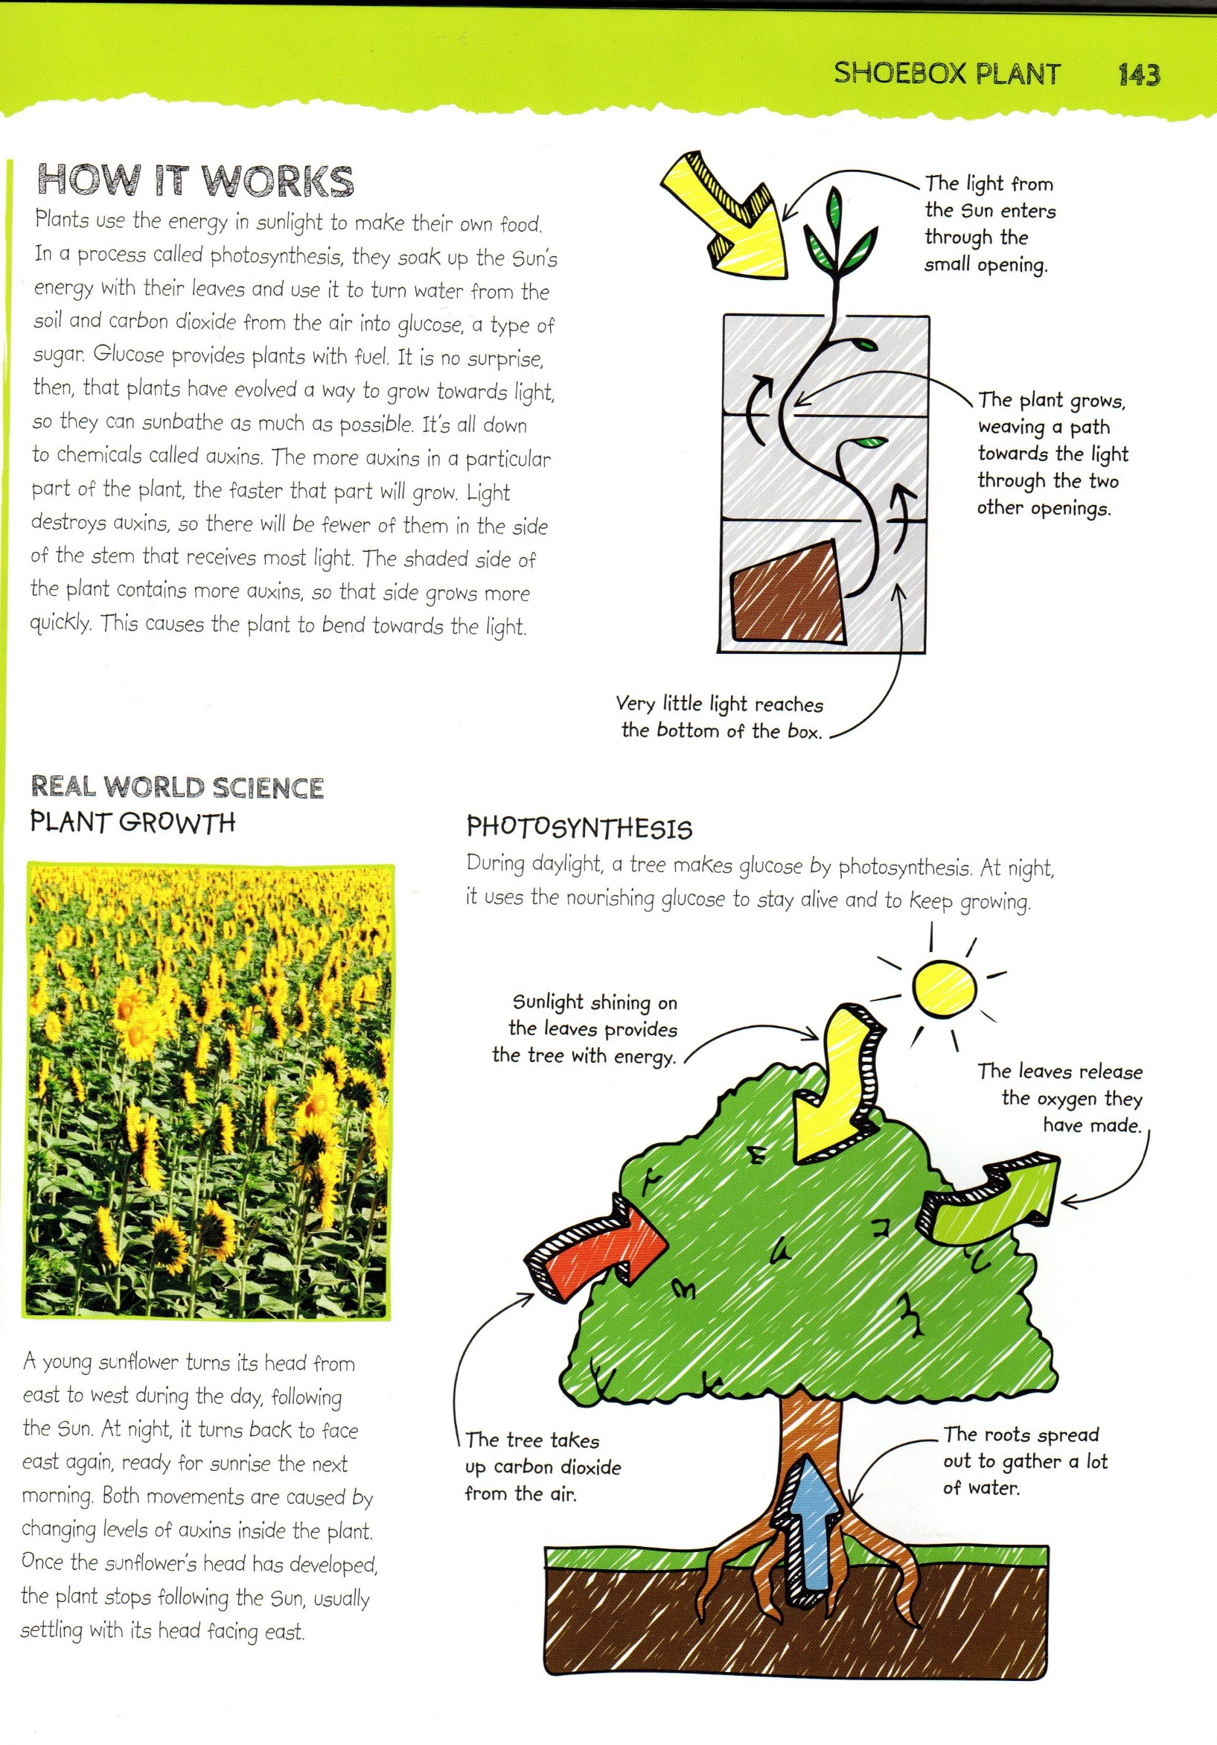
SHOEBOX PLANT
Note for parents, please do not share this information with the children as it is important, they see and experience the different stages:
In this experiment you will see how important sunlight is to a plant. You will challenge a bean seedling to find its way through a maze made inside a dark box, following just the tiniest beam of light. It will not take you long to set up the experiment, but you will have to wait for the results. It might take a week or more before you see young green leaves popping out of the top. Please note the captions with the arrows are for your information and I have outlined questions that you can ask the children and then discuss.
Part 1
Plants need food to ____ _____ and ___. Plants create their own food using energy from the ___. Roots spread out to gather the _____.
(water - stay alive – sun - grow)
Part 2
- Share the first paragraph with the children.
Questions you could ask… What is an obstacle course? What does ‘scramble’ mean? How can we find out if we do not know? What do you think the shoots will look like?
Show the instructions to the children. What are these? Why do they have numbers? What would happen if we there were no numbers? What do we need to do before we start following the instructions?
- Go through ‘WHAT YOU NEED’
Start to work through the instructions. The children can read the instructions with support. They will be writing the instructions later I recommend that ‘they’ take photographs or draw pictures as the go along to prompt their writing later.
Questions you could ask as you go through…
Instruction 2 – What will the broad bean need to grow? Where is the best place to put the cup?
The children will need help with the box but please encourage the children to do most of the construction independently. As you put the box together you could ask the children about the shapes and their properties e.g. Rectangle – Two long sides, two short sides and four corners. Cuboid – Six flat rectangle faces (you could extend by talking about how the sizes are not all the same), twelve edges and eight vertices.

Instruction 6 – What do you think the rectangles are for? What do you think is happening in our cup?

Instruction 8 – What does the plant need to grow? Will it get any light now that it is in the box? How will the light get to the plant? What do you think is going to happen? Do you think the seedlings will follow the maze?
Remember to take photographs and keep a record of your experiment so that you can write up the instructions for Ms Chohan to use with Monet Class.
In addition to instructions 1/2 you could also plant a broad bean in a clear cup using cotton wool so that the children can see the changes over time as it starts to shoot and grow. If you plan to do this, I have attached a ‘Bean Diary’ that the children can write/draw in as the plant grows.
Part 3
- How it works
Share the text with the children. This is quite complicated for this age group, but you will be surprised what they can recall… especially words like ‘photosynthesis’.
You might want to contact the other children and make this into a competition. Who has the tallest bean?
I would love to see some of these on our newsletter.
Have fun!
Mrs S

