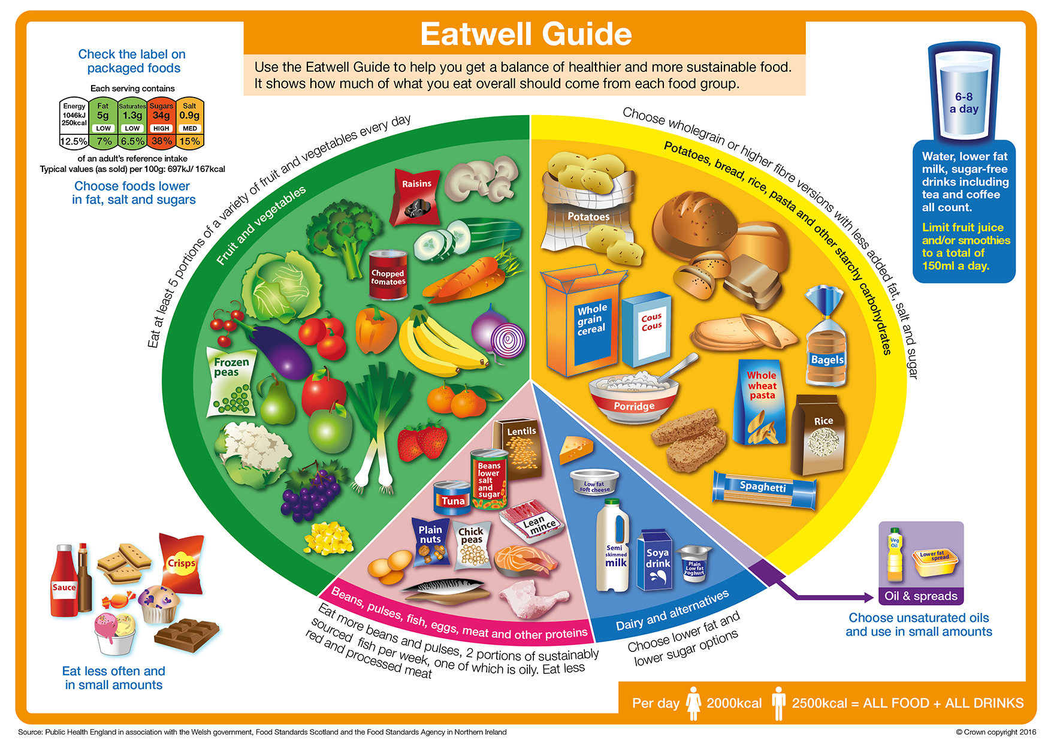

Eatwell
The Eatwell Guide shows the recommended proportions of food in the diet. You can view this more clearly here: https://www.nhs.uk/live-well/eat-well/the-eatwell-guide/

List 8 food from the Fruit and vegetables food group.

 | Do they grow in the UK? | When are they in season?
1.
2.
3.
4.
5.
6.
7.
8.

