What shall we do with the grumpy pirate?
What shall we do with the grumpy pirate?
What shall we do with the grumpy pirate?
Early in the morning.
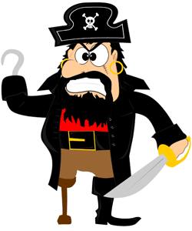
Hooray and up she rises, Hooray and up she rises,
Hooray and up she rises, Early in the morning.
Do a little jig and make him smile,
Do a little jig and make him smile,
Do a little jig and make him smile,
Early in the morning.
My ideas:

What shall we do with the ________________________________________________
What shall we do with the ________________________________________________
What shall we do with the ________________________________________________
Early in the morning.
Hooray and up she rises, Hooray and up she rises,
Hooray and up she rises, Early in the morning.
______________________________________________________________________________________________,
______________________________________________________________________________________________,
______________________________________________________________________________________________,
Early in the morning.
What shall we do with the grumpy pirate?
What shall we do with the grumpy pirate?
What shall we do with the grumpy pirate?
Early in the morning.
Hooray and up she rises, Hooray and up she rises,
Hooray and up she rises, Early in the morning.
Do a little jig and make him smile,
Do a little jig and make him smile,
Do a little jig and make him smile,
Early in the morning.
My ideas:

What shall we do with the ________________________________________________
What shall we do with the ________________________________________________
What shall we do with the ________________________________________________
Early in the morning.
Hooray and up she rises, Hooray and up she rises,
Hooray and up she rises, Early in the morning.
______________________________________________________________________________________________,
______________________________________________________________________________________________,
______________________________________________________________________________________________,
Early in the morning.

