Ten Hidden Squares

On the graph below there are 34 marked points.
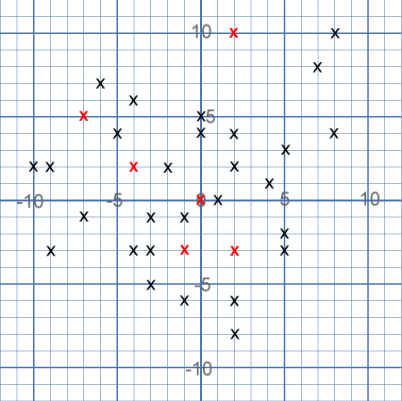
These points all mark the vertices (corners) of ten hidden squares. Each of the 6 red points is a vertex shared by two squares. The other 28 points are each a vertex of just one square. All of the squares share at least one vertex with another square.
All the squares are different sizes.
There are no marked points on the sides of any square, only at the vertices. (There are two near misses!)
Can you find the ten hidden squares?

Helpful Hint - Start with one point and look for others that make a square with it.
Don't forget that some squares may be tilted!

