Monet Planning
Timetable
22.06.20
 | Monday | Tuesday | Wednesday | Thursday | Friday
9.00-9.30 | Rainbow Games from school | Rainbow Games from school | Rainbow Games from school | Rainbow Games from school | Rainbow Games from school
9.30-10.30 | Set English Work | Set English Work | Set English Work | Set English Work | Set English Work
10.30-10.45 | Exercise  Freeze with Jump start Jonny  Link doesn’t work so just type it into google. | Exercise  I like to move it with Jump Start Jonny  Link doesn’t work so just type it into google. | Exercise  Wipe out with Jump Start Jonny  Link doesn’t work so just type it into google | Exercise  Shake it off with Jump Start Jonny  Link doesn’t work so just type it into google | Exercise  Everything is awesome with Jump start Jonny  Link doesn’t work so just type it into google.
11.00-12.00 | Set Maths work | Set Maths work | Set Maths work | Set Maths work | Set Maths work
1.00-3.00 | Science & Art 1 | Science & Art 1 | Science 2 | Science 3 | Science 1
3.00-3.30 | Reading for pleasure | Reading for pleasure | Reading for pleasure | Reading for pleasure | Reading for pleasure
3.30-3.45 | Diary Entry | Diary Entry | Diary Entry | Diary Entry | Diary Entry

Phonics/Spellings

There is a word search and a read, write, spell, check sheet to help the children learn the spellings on the school website.
Spellings | Year 1 | LO: Adding ‘s’ and ‘es’ to words.  cats, dogs, spends, rocks, schools, friends, thanks, catches, pushes, fetches.
 | Year 2 | LO: To learn homophones and near homophones conjunctions.  night, knight, blue, blew, hole, whole, because, so, that, or.

Another way to learn spellings could be to:
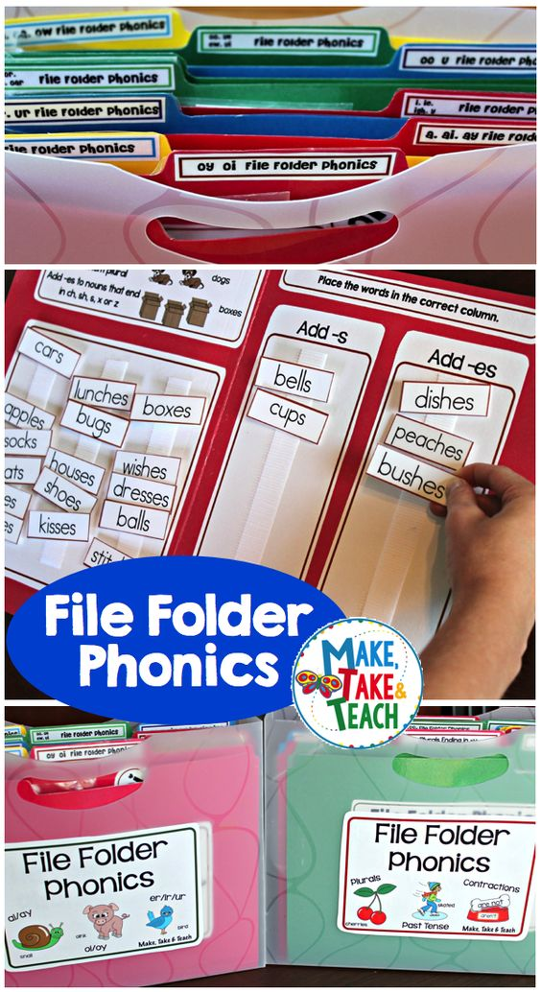
Another way to learn spellings could be to:
Draw the template in the picture.
Have the words written on a strip of paper.
Then the children can sort the words into the columns.

English
Monday | Year 1 & 2 | LO: To introduce the theme of growing up.  - Talk to the children and ask:  - What is it like to be six? Show a cake with six candles.  - Discuss birthdays and parties.  - Read 'The End' by A. A. Milne on Active learn.  - What is this poem about?  - How does the person feel about being six?  - Reread the poem, indicating the ages on your fingers.  - Develop understanding: Had just begun what?  - Why was the person ‘hardly me’?  - Not much more than what?  - I wonder what they mean by ‘just alive’: they haven’t been alive for very long yet, or they were alive but couldn’t do much yet … What do you think?
 | Activity | Discuss the poem:  - Do you feel like the person in the poem?  - What were you like when you were one/two (etc.)?  - How have you or your brothers or sisters changed as you’ve got older?
Tuesday | Year 1 & 2 | - Discuss growing up, using ‘What can you do now?’ assigned on Active Learn to stimulate talk.  - What can you do now that you couldn’t do when you were little?  - Undertake Activity 1.  - Use Think Alouds to write one of their sentences.  - Show ‘Success criteria: writing sentences’ assigned on Active learn.  - Discuss and add to the success criteria.  - Involve the children in checking the demo sentence for spelling of high-frequency words and applying phonic knowledge and skills.  - Undertake Activity 2.  - Share sentences, referring to the success criteria. Have you used a capital letter and a full stop?
 | Activity | 1. Talk Partners orally make up a sentence beginning ‘Now I am six (or five), I can …’ (e.g. ride my bike without stabilisers). It doesn’t need to rhyme.  2. The children each write their own sentences beginning ‘Now I am six (or five), I can …’.They can use ‘Sentence cards’ assigned on Active learn for support if necessary. They check their work.
Wednesday | Year 1 & 2 | - Read ‘Wait until you’re older!’ assigned on Active learn together.  - Relate the poem to the children’s experiences.  - What would you like to do but are not yet allowed?  - How does that make you feel?  - Note words for their feelings on paper.  - Read ‘Don’t Tell!’ by Irene Yates assigned on Active learn.  - How does this child feel?  - Who are ‘They’? What does the child in the poem mean by ‘Really a giant, inside’?  - Do you feel like this when you are not allowed to do things?  - Talk Partners discuss this briefly and then share their thoughts.  - What things might the child want to do?  - What if they were allowed to do them?
 | Activity | Discuss together:  - Did the child manage to do the thing or not?  - Did they decide to keep to the rules after all?  - What would you do in that situation?
Thursday | Year 1 & 2 | - Discuss ways of saying something is easy (e.g. ‘easy-peasy’, ‘a piece of cake’), including local expressions.  - Display and listen to ‘Peasy!’ by Brian Moses assigned on Active learn.  - What is the poem about?  - Does anything puzzle you?  - Is eating custard skin the toughest thing in the world?  - I wonder if they can really do all those things easily. Could you?  - What is your ‘toughest thing’ to eat? Allow Think Time.  - Share ideas and vote on each: easy-peasy, or the toughest thing in the world?  Listen to the poem again, encouraging the children to join in with ‘peasy’!
 | Activity | Introduce ‘Challenges’ Assigned on Active learn.  - Would this challenge be easy or hard?  - Why?  - Were you right about which would be easy or hard?
Friday | Year 1 & 2 | Reading for pleasure  I have uploaded an eBook onto the school website called ‘A magical muddle’.  Please read and enjoy
Maths

Monday | Year 1 | LO: To be able to use pairs to ten to find the complement to the next multiple of ten.  - Show 8 beads at the beginning of the 100 bead string on Bead string tool assigned on active learn with divisions of 10 labelled.  - Ask: How many more do we need to make 10? Show 18 beads.  - How many more to make 20?  - Can you see the pair to 10? 8 and 2.  - Show 28 beads.  - What's the next multiple of ten after 28?  - How many more do we need to make 30?  - Can you see the pair to 10?  - Repeat with 38, 48, 58 … 98.  - Choose a few and record the number sentence, e.g. 48 + 2 = 50, showing this on the bead string.  - Repeat with 26, 46, 86 & 96.  - Emphasise how if we know our pairs to 10 we can use this to work out how far it is to the next ten.
 | Activity | Children choose a number less than 10, e.g. 8, and record what needs to be added to make 10, to 18 to make 20, to 28 to 30 & so on until 98 to make 100.  The repeated pattern may help them.
 | Year 2 | LO: To be able to add pairs of 2-digit numbers by partitioning or counting on.  - Tell the children they will be adding 2-digit numbers.  - Choose two children to make 32 and 24 using place-value cards (Resource sheet 22 place value cards (1), Resource sheet 24a place value cards (2) and Resource sheet 24b place value cards (2) assigned on Active learn.  - Ask the children to add them: 32 + 24 =.  - Mimic this process using the Place-value cards tool assigned on active learn. Move the 10s together.  - How much have we got here? Move the ones cards together. And here? Altogether?  - Record:  32 + 24  = 30 + 20 + 2 + 4  = 50 + 6  = 56  - Discuss how we can also count up in 10s and 1s (so add 20 then 4).  - Ask a child to help you to draft an empty number line jotting to work this out.  - Point out that you get the same answer whichever method you use, so you can choose the one you prefer.  - Note that for both partitioning and counting up you always work with the 10s first.  - Write 73 + 21, 52 + 37, 54 + 26, and 44 + 35 on paper.  - Ask children to work them out in their book, using either strategy.  - Discuss which strategies they chose and why: adding on 21 for example is really easy using counting on, whereas they may have preferred using partitioning to work out 52 + 37 as counting on 37 is a little trickier.
 | Activity | Work through additions on Resource sheet 1501 ‘adding pairs of 2 digit numbers’ assigned on active learn, using place-value cards (Resource sheet 22 place value cards (1), Resource sheet 24a place value cards (2) and Resource sheet 24b place value cards (2) assigned on Active learn to support partitioning.  Can use a 1–150 grid (Resource sheet 734) assigned on active learn to help counting on in tens and ones.  Find which method each child prefers so they each have a reliable method.
Tuesday | Year 1  Activity | LO: Use pairs to ten to find the complement to the next multiple of ten.  - Tell children they will use pairs to ten to find how much to the next multiple of ten.  - Show a 0–100 beaded line on Bead string tool assigned on active learn.  - Ask them to place a tag on 7.  - What do we add to 7 to make 10?  - Draw a hop labelled + 3 from 7 to 10.  - Ask them to place a tag on 17.  - What do we add to 17 to make 20?  - Can you see the pair to ten?  - Draw a hop labelled + 3 from 17 to 20.  - Repeat this, finding the complement to next multiple of 10 for 27, 37, 47 … 97.  - Ask them to mark 68.  - What’s the next multiple of 10?  - How many beads do we add to 68 to make 70?  - Draw a hop from 68th bead to 70, and label it +2.  - What number sentence can we write?  Complete worksheet resource sheet 1500 ‘how many more to the next 10?’ assigned on active learn.
 | Year 2  Activity | LO: Add pairs of 2-digit number by partitioning or counting on.  Remind children of the two strategies for adding which we revised yesterday.  Return to question 9 from Part B on Resource sheet 1501 ‘adding pairs of 2 digit numbers’ assigned on active learn: 31 + 46.  Ask children to think, pair, share how to solve this.  Model swapping numbers over (as you can add in any order), then counting up 30 and another 1 to find the answer.  Use Random number generator tool assigned on active learn, to generate two numbers up to 50.  Ask children to work with a partner to decide which strategy to use to add the two numbers.  Look for examples of changing the order of the question to help, using number bonds, etc.  Complete worksheet ‘adding pence amounts’ assigned on school website.
Wednesday | Year 1  Activity | LO: Add single digit numbers to 2-digit numbers using patterns.  - Write number sentence 4 + 5 = on paper.  - Will the answer be less or more than 10?  - How do we know?  - Children discuss in pairs.  - Underneath write 14 + 5 =.  - What is similar about these two number sentences?  - Children discuss with their partner.  - Draw out that the sentences are nearly the same except that the 4 has become 14 in the second sentence.  - Recap that 14 is made up out of a 10 and a 4.  - Bearing this in mind, what is the answer to 14 + 5?  - Children discuss again with their partner and then feedback their answers. How did they work it out?  - Reinforce that we already knew that 4 + 5 = 9 so 14 + 5 = 19.  - Repeat with 3 + 5 = / 13 + 5 = and 3 + 4 = /13 + 4 =.  Complete worksheet Resource sheet 1511 addition patterns assigned on active learn.
 | Year 2  Activity | LO: Subtract by counting up or counting back.  - Tell children you want to subtract 43 from 67.  - Write 67 – 43.  - Explain we can subtract by counting back in tens and ones or we can count up from the smaller to the larger number to find the difference.  - Point out that in 43, the 3 is less than the 7 in 67.  - This means it is easy to count back 4 tens and 3 ones.  - Model hopping back in 10s then subtracting 3 on Number line tool assigned on active learn.  - I could also count up to find the difference.  - Remind children that Frog can help us to count up to find a difference.  - Mark 43 on the 0–100 line,  - What’s the difference between 43 and 50?  - Draw a hop and label it 7.  - What’s the difference between 50 and 60?  - Draw a hop and label it 10.  - And the final hop is another 7.  - So what’s the difference between 43 and 67?  - Add the hops 7 + 10 + 7 = double 7 is 14, 14 + 10 = 24.  - Record 67 – 43 = 24 reading the – sign as subtract.  - If I am solving 71 – 4 = (read as 71 subtract 4) will it be easier to count up or count back?  - Take feedback, demonstrate both ways and draw out that as we’re subtracting such a small number it’s easier to count back.  - Point out that we can use counting up (finding a difference) or counting back to solve subtractions, and so we choose whichever is easier or quicker depending on the numbers.  - If the numbers are close to one another, it’s usually easier to count up.  - If numbers are far apart, it’s often easier to count back.  Solve subtractions in Part A of Resource sheet 1513 Subtractions assigned on active learn.  Discuss method: Is it easier to count up or count back? Why?  Support children, helping them to use a landmarked line (Resource sheet 1088 landmark line assigned on active learn) to count up writing the smaller number on LHS and larger on RHS hopping to the next ten, then on in tens, then ones.
Thursday | Year 1 | Play Sea shack smash 1.9 assigned on Active learn.
 | Year 2 | Play ‘Sea shack smash 2.6’ assigned on active learn.
Friday | Year 1 | Play ‘balloon pop 1.13 assigned on active learn.
 | Year 2 | Play ‘tumble down den 2.7 assigned on active learn.

Topic

Science 1  Art | LO: To learn about animals that live in the sea.  Watch the video clip from BBC Bitesize: BBC Bitesize Animals that live in the sea  Using papier-mache, junk modelling, clay or other forms of media, recreate your chosen animal and create an ‘under the sea’ display with fact cards about each animal using facts gathered from the clip.  I look forward to seeing photos of your art work.  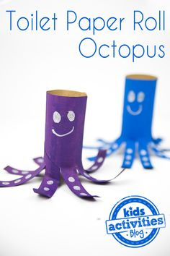  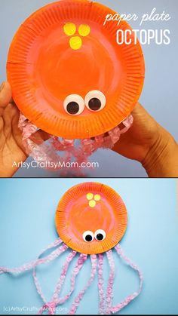  Here are some ideas:  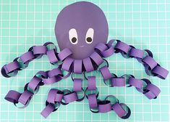  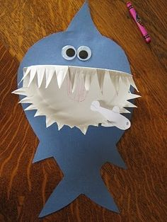  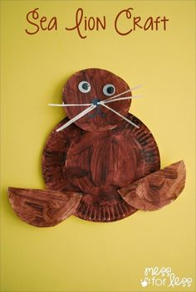  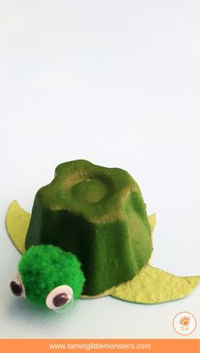  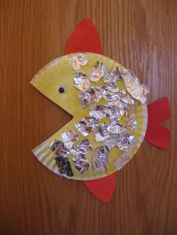  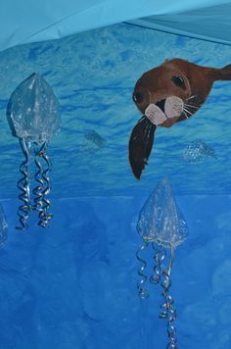  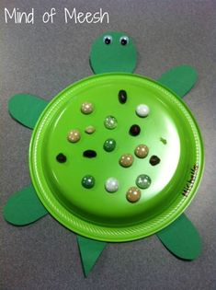
Science 2 | Go through the PowerPoint slide ‘Sea Creature Facts’ assigned on School website.  Play the interactive game ‘Under the sea – What am I?’ assigned on School website.
Science 3 | Complete the fun worksheet ‘Crack the codes under the sea’ assigned on School website.

