Subject home learning tasks: 18/05/2020
Here are some foundation related tasks that you could do at home.
Task 1, 2 & 3: Science/DT/English
Outcome: To think about and have a go at answering the questions: “How can astronauts protect themselves from the Sun on Mars?”
Task 1: Explain to your child that currently there is a lot of effort put into going to Mars and finding out if there is life on the red planet (see ExoMars 2020). Explain that if an astronaut was to visit and stay on Mars, they would need a way to protect themselves from the dangerous UV light as Mars does not have an Ozone layer like the Earth does. The astronaut would need a “home” where they could live in without the suit. This home would need to allow light to go in, so that the astronaut could get sunlight for vitamin D and for the benefit of their mental health as well as allow them to grow plants for food. But this home must also protect them from the UV light so that they wouldn’t burn. (a background since file will also be uploaded)
Ask you child to plan and carry out an investigation as to what materials they could use to have the shelter, or to plan for a way to block UV light entering through a window. Help them by brain storming some ideas with them, but let your child come up with their experiment independently.
Task 2: Have your child build a prototype model of the “home” or environment the astronaut would live in on Mars. This could be accompanied with a small poster describing/explaining the model.
Task 3: Have your child pretend to be that astronaut and record what life might be like on Mars. They may choose to do it as a diary, a story, a poem, or perhaps they will write a script and act it out on camera? Brainstorm some ideas and let them choose.
Task 4: History
Outcome: To look at what life was like for Viking people in Britain.
Task: Explain to your child that they are going to learn about the life of Viking people in Britain. Ask them about why they think the Vikings would want to move and settle in Britain. They should be able to give some good ideas, as they have looked at similar topic regarding the Anglo-Saxons.
Using the Viking life fact-file (see attached), have your child draw two people, a Viking and a person from modern days and write up similarities and differences. The similarities and differences could be done in different colours (such as red and green)

Task 5: ICT
Outcome: To learn about using PowerPoint (or similar programs)
Task: Explain that, when giving an explanation or presentation to a group of people, using visual aids help them focus and remember the information. In modern times, people use programs like PowerPoint to create presentations. Explain that they will learn how to use this program to be able to give interesting presentations, as well as maybe have some fun while doing it too!
For this session, simply show them how to make new slides, and the different types that exist, as well as some basic design stuff to make them look a little interesting.
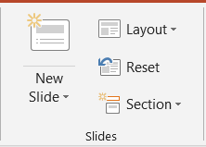
Clicking on the image above “New Slide” creates a simple slide with a title box and a contents box. By clicking on the words themselves, it opens up a drop down box, allowing you to chose a different layout for that slide.
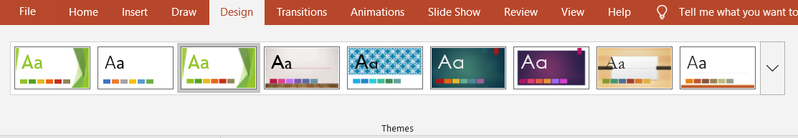

Under the “Design” tab, you can choose different themes for your slides. By clicking on the arrow, you will get a dropdown box that shows you all the available themes. Hovering (but not clicking) over one of them gives you a preview of what the slide would look like. Left clicking on it will apply it to ALL the slides, while right clicking will provide you with options.

