UK food labels

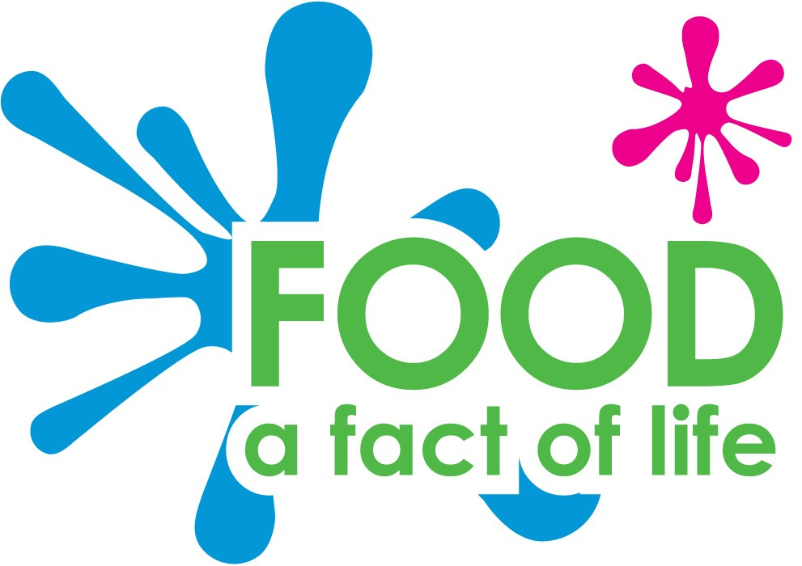

**Blackberries**

**Argyll**

**Scotland**

**Shortbread**

**West Lothian**

**Scotland**



**Soda bread**

**County Down**

**Northern Ireland**

**Potato**

**County Antrim**

**Northern Ireland**



**Leek**

**Flintshire**

**Wales**

**Lamb chops**

**Monmouthshire**

**Wales**



**Cheddar cheese**

**Somerset**

**England**

**Plum**

**Worcestershire**

**England**



**Cornish pasty**

**Cornwall**

**England**

**Beef**

**Yorkshire**

**England**

**Pork**

**Norfolk**

**England**



**Apple**

**Kent**

**England**



**Cauliflower**

**Penzance**

**England**



**Chicken**

**Somerset**

**England**



**Salmon**

**Aberdeenshire**

**Scotland**



**Oysters**

**Kent**

**England**

