Session 1 Challenge one
Collect a different coloured token for each form of communication:
- Text
- Email
- Twitter
- Facebook
- Instagram/Kudos
- WhatsApp
- Snapchat
- Viber/Messenger
- Skype/phone calls
Create a Venn diagram (see templates) to show how you might use these forms of communication for:
- Formal purposes (e.g. making a complaint)
- Functional purposes (e.g. making arrangements to meet)
- Chatting and sharing with friends
Now make a Venn diagram (see templates) depending on the number of recipients:
- 1 recipient
- 2-3 recipients
- Multiple recipients
Read the emails, texts, snapchats and tweets about to be sent – can you spot the good ones that will get the message across clearly without causing offence or confusion? Are there others that might be misinterpreted, cause a negative reaction, or upset someone? What might happen if you sent these communications without thinking about how they might come across? Look at the posters - why do people need to remind themselves to think before sending or clicking?
Can you come up with 1-2 quiz questions for ‘think before you send’?
Three ring Venn template

Forms of communication template
Formal purposes

Functional purposes
Chatting and sharing with others

Number of recipients templates

1 recipient

Multiple recipients
2-3 recipients

WhatsApp
A friend has texted/messaged to ask if you and another couple of friends would like to meet up. You are in the middle of something and can’t make an arrangement at that moment. Possible responses:
- Am busy – text later
- Having a ‘mare at mo! Let me know where you end up
- Not now
- Can I let you know in a bit? Currently surrounded by paint, LOL!

Email
You emailed a company to make a complaint recently about a faulty item of clothing. They responded by suggesting you take the item back to a shop (which is not possible) or return it by post (at your own cost). Possible responses:
- I will not pay for return postage – this is not acceptable. I will make sure that I tell my friends not to shop with you as this is rubbish customer service. Please refund my money immediately or I will take this further.

- Thank you for your email. I am unable to return the item to a shop, and am a little disappointed that I am expected to pay for return postage on a faulty item. Would it be possible for the postage to be refunded along with the money for the item itself? I would be very appreciative if you could let me know before I send the item back.
Kind regards

Social network status (e.g. Facebook)
You cancel going to a friend’s house as you feel unwell. A bit later, feeling better, you head out to the park and take a ‘selfie’ that you want to post online. The friend you cancelled on is a Facebook friend. Possible outcomes:
- You post the selfie online with a caption ‘feeling a bit better – sorry I missed out on catching up with (tagging your friend)’
- You post the selfie online with no caption
- You post the selfie online with the caption ‘great afternoon in the park’
- You do not post the selfie online

See posters document
Challenge two
Look at the given emojis and text-talk abbreviations and come up with 1-2 words to describe what the emojis might mean, and what you think the text-talk/abbreviations mean.
Text-talk/abbreviations:
LOL
SYS
BTW
JK
TTFN
RUOK
Discuss the following questions:
- Do you all think they mean exactly the same thing?
- Do you think older/younger people they know understand emojis and text-talk/abbreviations in the same way as you do?
Now look at the how the ‘grimacing face’ emoji changes from one system to another:
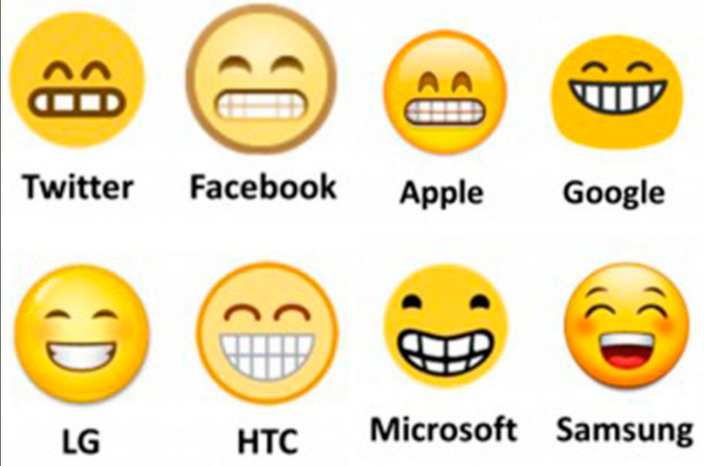

- Do you think the meaning of them has changed?
- What do you think you should consider when quickly sending emojis or using text-talk to people?
Can you come up with 1-2 quiz questions for ‘using emojis and text-talk’?
Text-talk/abbreviations for teacher
LOL – laughing out loud
SYS – see you soon
BTW – by the way
JK – just kidding
TTFN – ta-ta for now
RUOK – are you ok?

